Change of Harmonic Number in CBETA
Stephen Brooks 2017-Jan-10

Definitions
The CBETA machine in its initial configuration has a 1.3GHz RF cavity frequency.
- h = the harmonic number = number of RF wavelengths in the circumference of passes 1 through 3 (the 4th pass is 1.5 wavelengths longer);
- N = the injection subharmonic = the delay between injection of successive bunches, measured in RF periods.
CBETA has three operating modes: commissioning mode with a single bunch injected every 4 turns, eRHIC-like mode (the most complex, mostly discussed here) and high-current mode with a bunch injected every 4 RF periods (N=4). See design report section on bunch pattern for details.

Proposed Change
The new bunch filling scheme in eRHIC mode is shown in the charts below.
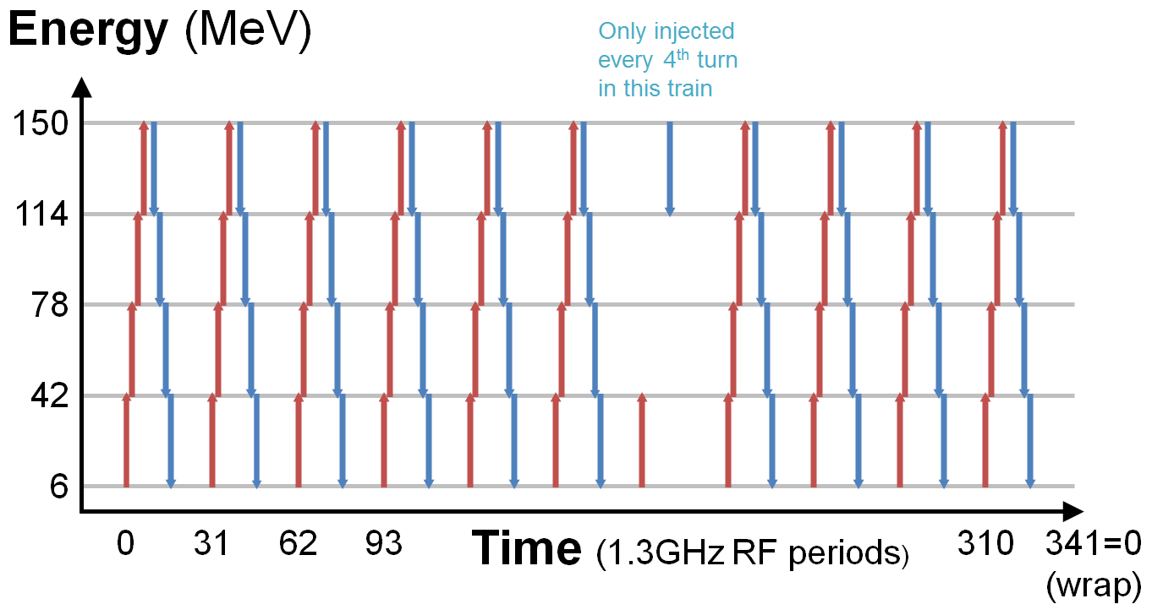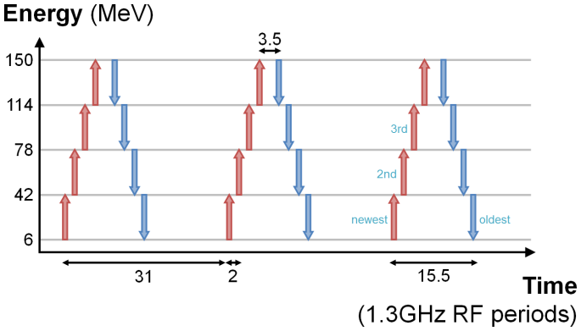
The diagrams show time structure through the linac. Red arrows are accelerating bunches and blue arrows are decelerating bunches. This new scheme has h=343 and N=341. The previous baseline scheme had h=333 and N=335, with another option considered where h=335 and N=333. The table below compares these three schemes. If or when an eRHIC prototype 650MHz cavity is installed, the ring circumference will be adjusted to h_{650MHz}=171 (equal to 342 1.3GHz wavelengths, i.e. one wavelength shorter) and N_{650MHz}=17 will be used to produce 10 trains.
H | N | Max number of eRHIC-like trains | Primary laser frequency (MHz) | Length change of each side of ring (vs. h=333) (m) | Gap between diagnostic bunches
343 (new) | 341 | 11 | 41.935 | 1.153047915 | 9.5 periods = 7.3ns
333 (old baseline) | 335 | 5 | 19.403 | 0 | 6.5 periods = 5.0ns
335 (old option) | 333 | 9 | 35.135 | 0.230609583 | 9.5 periods = 7.3ns
The main benefits of this change are:
- 11 trains in eRHIC mode rather than 5, which allows the 1mA average current Key Performance Parameter to be achieved with 25.6pC/bunch instead of 60.6pC/bunch, assuming all trains filled except the diagnostic train that is ¼ filled.
- Gap between accelerating and decelerating diagnostic bunch increased from 5.0ns to 7.3ns, which helps reduce BPM ringing effects.

Constraints
The following table shows the considerations in making this change.
Source | Criterion | Constraints
eRHIC/BNL | Non-overlapping bunch trains analogous to eRHIC | N and h must be close, with the inter-bunch spacing being |N-h| wavelengths  N must have the desired number of trains as a factor
Cornell ERL | High-current mode allowed with all buckets filled at "2.6GHz" | h must be odd, since N will be 4 for this mode, and only odd h avoids "collisions" with 2 bunches per bucket
eRHIC/BNL | Inter-bunch spacing in trains must be "650MHz" (to give a good platform to test high-frequency diagnostics and maximum similarity to eRHIC bunch trains) | The spacing |N-h| must equal 2, so h=N-2 or h=N+2 (therefore N is also odd)
Diagnostics | Bunches filled in direction such that extra length in final splitter adds to spacing | h>N (therefore h=N+2) so the circumference is always "longer" but gets longer still for top energy
eRHIC/BNL | Good average current in eRHIC mode, so fit many bunch trains in the ring | N should have a large factor less than h/18 (which corresponds to complete filling)
Laser | Laser primary frequency <50MHz to allow individual pulse suppression | This is OK up to 11 bunch trains, while the options for 13 or 15 trains go a bit over the limit
eRHIC/BNL | Good filling scheme when 650MHz cavity is installed | A practical small adjustment to splitter lengths should give a good scheme when this modified h is halved
Walls | Circumference must still fit in the L0E hall including shielding etc. | There is an upper limit on h (To Be Determined), not too far from the h=333 value in the CDR
Lattice (optional) | Preference for fitting an injector diagnostics beamline before the linac | h should be slightly above 333 to create ~1 metre of extra room
The proposed scheme satisfies all these conditions. There are no known problems with this change.

Areas Affected by this Change
- Diagnostics via bunch separation;
- Hall and shielding layout via increase of size of ring;
- Lattice and girders via increase of path length in splitters and FFAG straight;
- Gun laser via change of frequency.

